PWA Video 17 cache versioning

<https://www.youtube.com/watch?v=g9LfyCZjeKI>

the cache only will reinstall and update when we change the html is if there is a new version, but which version should the service worker use?

When updating asset files need to also delete the ole cache version

Do this in the activate event

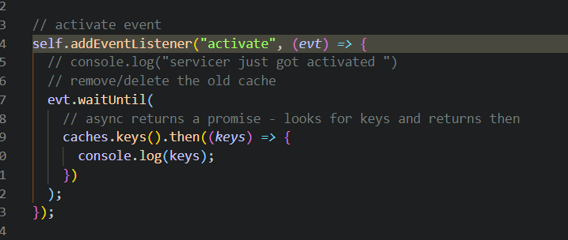

Console log shows bot the old and new cache assets

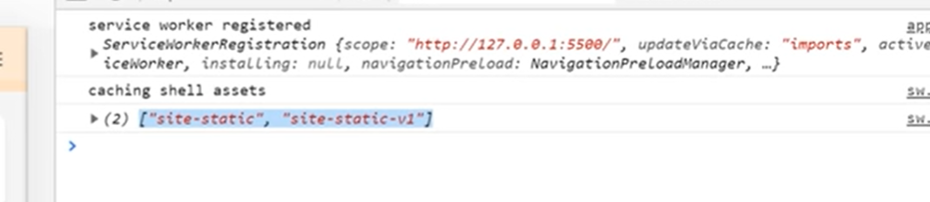

We want to del the old cache – if the current cache key is not the same as the one in the staticCacheName delete it.

